This project tests students' understanding of logical properties, pseudo-classes, pseudo-elements, flex-box and grid.

Link to the project <https://lsindhur.github.io/UnitTest2/>

Replicate the project on your own. Some important Instructions to follow along 🔽

**Important Note**:

⛏️ Use only logical properties instead of physical properties wherever they apply.

⛏️ Apply the DRY (Don’t repeat yourself) principle and use common class for elements with similar styling. Do not write repetitive CSS.

**Step1: Universal reset**

1. Apply universal reset of padding, margin and make box-sizing default to border-box**.**

**Step 2: Body**

1. Apply font-family:sans-serif
2. Apply Background color : #ffeae0

The body consists of two parts : Navbar and the content below it. Work on each part individually.

Navbar:



Content:

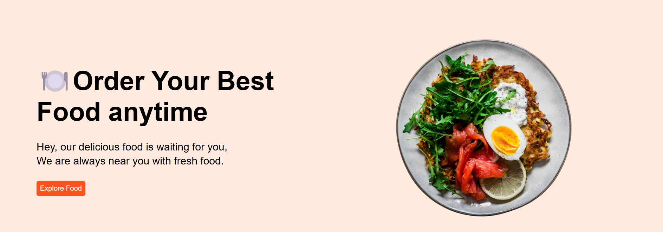

**Step 3: Navbar**

1. The orange color used for the text and sign-up button is #ff511c
2. On hover sign-up button should have a color of #e2460f
3. On hover sign-in button should have black color with white text.
4. On hover Home, Menu, Services, About Us and Gallery should have bottom border with the color #ff511c

**Step 4: Content**

1. Use window + . (Window and period symbol) shortcut to find emojis on vs code. Update the emoji before the headline using CSS. Do not include it in html code.
2. Explore food button also uses background color of #e2460f on hover.
3. The content consists of two divs. One for the image and another for the rest.
4. Insert the image inside a div and use flex/grid to position image on the right side of the page. Apply max-width of 50% to the div.
5. Apply max-width of 700px to the image.